COMPUTERS AND THE INTERNET

A desktop computer is an electronic device which enables us to write and print documents, play video games, search for information or stay in touch with other people over the Internet, and much, much more. It is also referred to as a personal computer (PC), although this expression used to be a brand name, like Macintosh.

Computer parts
A computer has many parts. Some are inside the computer case; they are called the internal components. These inner parts are: motherboard, central processing unit (CPU), graphics card or video card (or 3D accelerator), sound card, hard disk drive (HDD), memory (RAM), CD or DVD drives, network card, power supply unit. These parts are all connected with cables or attached directly to the motherboard. Some components, like the CPU and the video card, mustn't get too hot, so we cool them down using fans or even a water-cooling system. Also, some components can be external, like an external disk drive, which can serve as a back-up storage unit.
Some computer components are connected to the case by a USB cable and are not inside the case. Some are even wireless. These external devices can be divided into input and output devices. Output devices are: computer screen or monitor, printer, speakers. Input devices are: keyboard, mouse, scanner, webcam, microphone. Instead of a microphone and speakers you can use a headset. Some input devices are for playing video games; joystick, gamepad or joypad, racing wheel for playing driving simulation games.

Computer programmes
All the parts mentioned above are called computer hardware. They are the physical part of a computer. But a computer would be useless to a common person without its software; the programmes that are installed on it and enable the user to perform different tasks. The most important piece of software is the operating system, like Windows or MacOS or Linux, which provides an environment for all the other programmes. Some programmes are more important or useful than others. Word processors (like Office Word) and spreadsheet programmes (like Office Excel) used to be considered so useful and valuable that people bought computers just to be able to use a certain programme like that. Such programmes that manage to sell by themselves the hardware they run on are called 'killer applications'.

The Internet
A computer can be used to access the Internet. The Internet is a network of computers all over the world connected to each other. It was first developed for the needs of U.S. army and later found civilian use at universities. A very large and well-known part of the Internet is the World Wide Web (WWW).
For a dial-up connection (over telephone wires) you need a modem (modulator-demodulator). Most people nowadays access the Internet over optical cables and need a network card inside their computer. You also need an Internet Service Provider (ISP), a company which makes sure, for a fee, that you are connected to the Internet.
To access the Internet on your computer you need a browser, a programme like the Internet Explorer or Mozilla Firefox. It helps you navigate or 'surf' the many web pages or websites that exist on the Internet. Many people and companies make their own home pages, where they introduce themselves. If you are searching for information, you can use a search engine (Google, Yahoo, Najdi.si), a website which finds you other websites using the keywords you provide.You can also download movies and music on your computer or upload information on the Internet. You can stay in touch with your friends or make new friends using chat programmes or social networks like Facebook, Google+, and Myspace. You can also email your friends and business partners.

Electronic mail
E-mail programmes (like Outlook Express) and e-mail websites (like Hotmail and Gmail) enable the user to send and receive letters over the Internet. Unlike regular mail, this process is free and your letters arrive instantly. All you need to know is the e-mail address of the person you want to contact. A typical e-mail address looks like this; john.smith@gmail.com. The first part is the user name, the second is called the domain name. They are separated by the @ sign, which has many names in different languages, but is usually pronounced in English as 'at'.

EXERCISES
- Translate the following words and phrases into Slovene.
desktop computer ___________________ internal ___________________
external ___________________ software ___________________
hardware ___________________ user name ___________________
domain name ___________________ social network ___________________
browser ___________________ network card ___________________
- What do the following acronyms stand for?
PC ___________________ CPU ___________________ ROM ___________________
RAM ___________________ WWW ___________________ ISP ___________________
CD ___________________ DVD ___________________ OS ___________________

- In a few sentences, explain what you mostly need your computer for.
___________________________________________________________________________
___________________________________________________________________________
___________________________________________________________________________
___________________________________________________________________________
___________________________________________________________________________

- Find 10 words for computer parts in the square. All directions are possible.
M Y D M A P C M S P H V G B A
O R R R X Z S O L J L A S I M
T O P Y I U Y U V V X O G C T
H M H U O V I S W A B H S Q F
E E E H W E E E R O T I N O M
R M W S X M B F Z G Z X U J F
B D O U A N O M N F F N Q K R
O E R I L C I P X M L T B E J
A Z W A S P E A K E R S T Q Y
R J N P O U C A K R T N H W P
D M X Y W B K F B M I N Z P V
W A L N R M Y Z N R A T L O T
R E N N A C S E P F G U L A P
T S Y R H Z T R K E B U H P I
O K D D X D X I F X W A W Z N

CASE
DRIVE
KEYBOARD
MEMORY
MONITOR
MOTHERBOARD
MOUSE
PRINTER
SCANNER
SPEAKERS

- Solve the crossword puzzle.
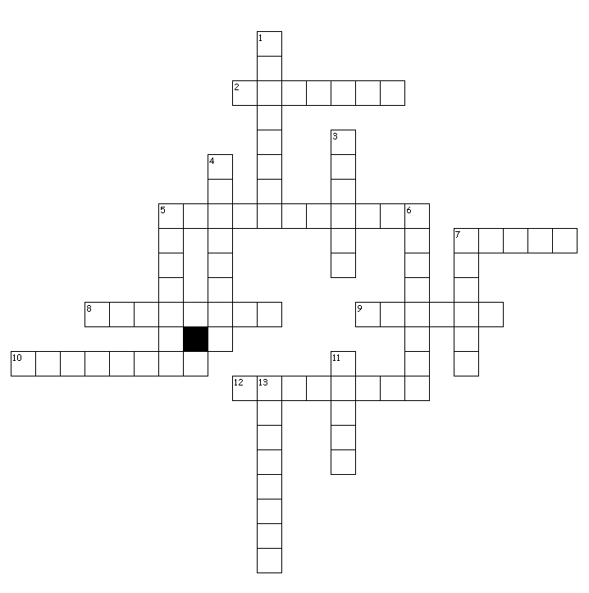

Across
2. a programme for navigating the Internet
5. a main internal component
7. CD, DVD, hard...
8. programmes
9. to transfer data to the internet
10. an audio output device
12. an input device with keys

Down
1. physical components
3. RAM
4. inner
5. a video output device
6. to transfer data from the Internet
7. the second part of an e-mail address
11. a device for a dial-up connection
13. outer

KEY FOR EXERCISES
- namizni računalnik, notranje, zunanje, programska oprema, strojna oprema, uporabniško ime, ime domene, socialno omrežje, brskalnik, mrežna kartica
- personal computer, central processing unit, read-only memory, random access memory, world wide web, internet service provider, compact disc, digital versatile disc or digital video disc, operating system
- Across: 2-browser, 5-motherboard, 7-drive, 8-software, 9-upload, 10-speakers, 12-keyboard. Down: 1-hardware, 3-memory, 4-internal, 5-monitor, 6-download, 7-domain, 11-modem, 13-external

